Name Period
3-117 Check Point

This problem is a checkpoint for unit rates and proportions. It will be referred to as Checkpoint 3.

In parts (a) through (c), use the given information to find the unit rated. In parts (d) through (f), write and solve a proportion based on the given information.

a. If 2$\frac{1}{4}$ pounds of bananas cost $1.89, what is the cost per pound?

b. What is the weight per cm?

Weight (g) | 9 | 12 | 18 | 30
Length (cm) | 15 | 20 | 30 | 50

c. Use the graph at right to find the refill cost per bottle. | 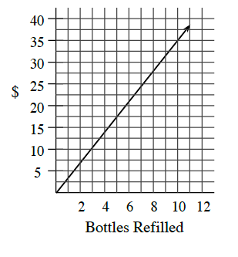

d.) If 200 vitamins cost $4.75, what should 500 vitamins cost?

e.) If a basketball player made 72 out of 85 free-throw attempts, now many could she expect to make in 200 attempts?

f.) A cookie recipe uses $\frac{1}{2}$ teaspoon of vanilla with $\frac{3}{4}$ cup of flour. How much vanilla should be used with 5 cups of flour?

