Name Period
Integer Practice for Re-take
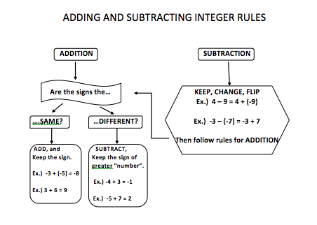

Multiplication and Division Rules:

Same sign = Positive product
Different Sign = Negative Product

Evaluate:

1. – 4 + 7 = 2. -5 – (-8) = 3. -5 + 9 =

4. -5 – 8 = 5. 8 – (-7) = 6. -5 + (-5) =

7. -4(6) = 8. -4(9) = 9. $\frac{-12}{6}=$

10. $\frac{36}{-6}$ 11. -5 + 9 = 12. -6(-8) =

13. $-9 ÷\left(-3\right)=$ 14. -6 + 12 = 15. -3 – (-9) =

16. $\frac{-81}{-9}=$ 17. -7(9) = 18. 42$÷\left(-6\right)=$

19. -2 + 8 = 20. 9 – (-8) = 21. -3(9) =

22. -5 – (-9) = 23. -3(-4) = 24. -2 – (-9) =

25. Edward has $220 in his bank account. If he withdraws $55 from his account, what is the balance in his account?

26. A roller coaster begins at 90 feet above ground level. Then it descends 105 feet. Find the height of the coaster after the first descent.

27. On the first play, the football team lost 6 yards. On the second play, the team lost 5 yards. What was their total change in yards?

28. A mountain climber climbed down a cliff 50 feet at a time. He did this 5 times in one day. What was the overall change in his elevation?

29. The price of jeans was reduced $6 per week for 7 weeks. By how much did the price of the jeans change over the 7 weeks?

30. Clark made four of his truck payments late and was fined four late fees. The total change to his savings from late fees was -$40. How much was one late fee?

31. Jan received -22 points on her exam. She got 11 questions wrong out of 50 questions. How much was Jan penalized for each wrong answer?

32. Louisa’s savings change by -$9 each time she goes bowling. In all, it changed by -$99 during the summer. How many times did she go bowling in the summer?

